ID121 Illustration-Cute Borders & Backgrounds

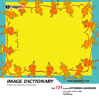
Quantity：75 images
Size：33MB
Format：21cm X 29.7cm / 300dpi
High-Resolution：AI/ JPG (CMYK)
/ 3508 x 2480 pixels
Low-Resolution：BMP(RGB) / 842 x 595 pixels

This collection contains a wide variety of cartoon illustrations of frames, which can be used as the backgrounds of business correspondence and announcement, posters or Web designs. These templates provide your clients with a large space for re-creation, so as to fit their professional quality requirements or other specific needs.

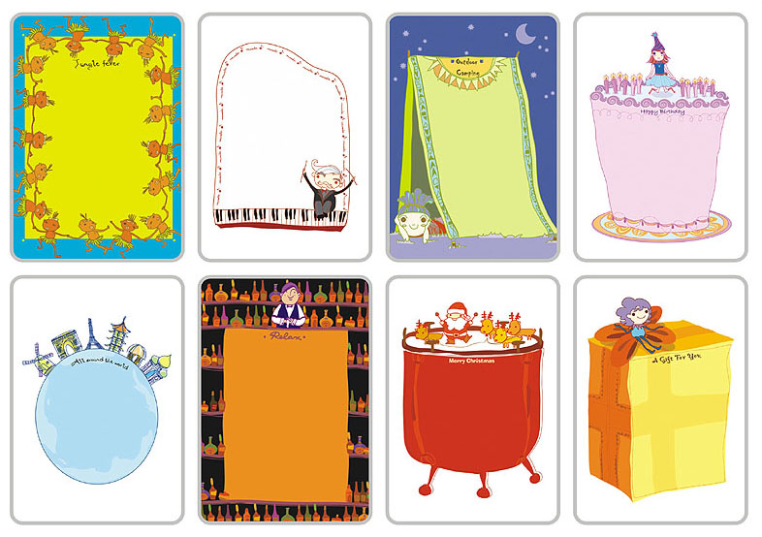
Target users：Web designers/editors, design artists, ad agents, related business people and students.
Suggested retail price：US$49

ID122 Synthetic Design III
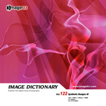
Quantity：75 images
Size：33MB
Format：21cm X 29.7cm / 300dpi
High-Resolution：JPG (CMYK) / 3508 x 2480 pixels
Low-Resolution：BMP (RGB) / 842 x 595 pixels

This volume contains various mesmerizing images. With different combinations of colors and tones, these synthetic designs create strong, dynamic and fashion-led visuals. Variants in shapes and figures make Synthetic Design III even more impressive.

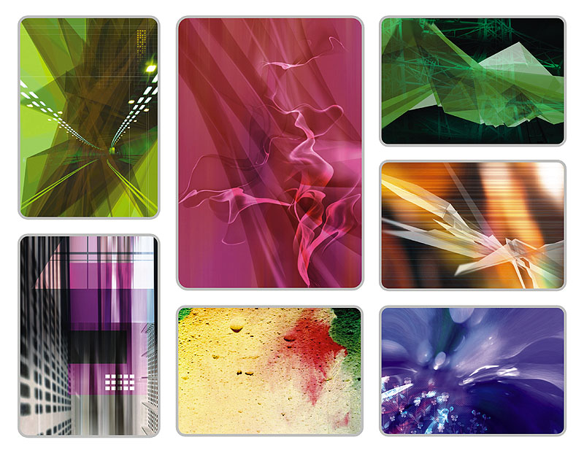
Target users：Web designers/editors, design artists, ad agents, related business people and students.
Suggested retail price：US$49

ID123 Face Close-ups

Quantity：75 images
Size：33MB
Format：21cm X 29.7cm / 300dpi
High-Resolution：JPG (CMYK) / 3508 x 2480 pixels
Low-Resolution：BMP (RGB) / 842 x 595 pixels

Your face tells all. That was the motive behind this CD. Face Close-ups, as it is, features different facial images. These images convey a wide range of human emotions, including tolerance, trust, hurt, etc. Delicate face features are genuinely captured and represented in this collection.

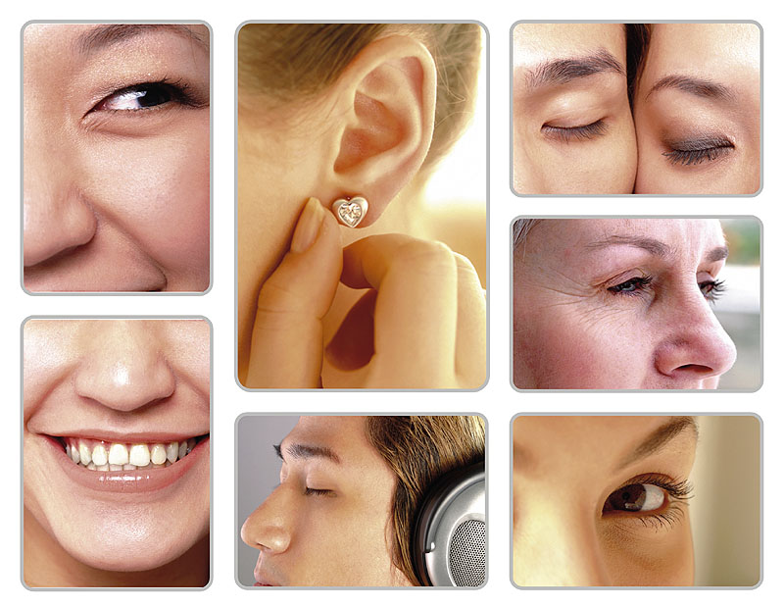
Target users：Web designers/editors, design artists, ad agents, related business people and students.
Suggested retail price：US$49

ID124 Herbs & Spices
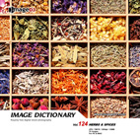
Quantity：75 images
Size：33MB
Format：21cm X 29.7cm / 300dpi
High-Resolution：JPG (CMYK) / 3508 x 2480 pixels
Low-Resolution：BMP (RGB) / 842 x 595 pixels

This collection covers a wide variety of herbs, flowers, and grasses. Different layouts with various combinations of herbal materials create brightly colorful visual effects. These pictures were all shot in the natural environment. Herbs & Spices particularly features various ancient Chinese medicines and remedial materials.

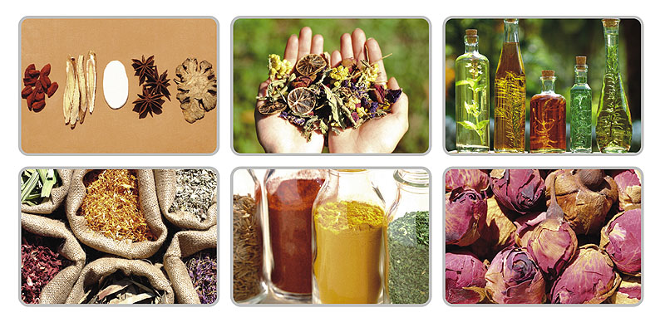
Target users：Web designers/editors, design artists, ad agents, related business people and students.
Suggested retail price：US$49

ID125 Lights & Shadows II
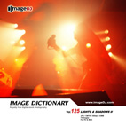
Quantity：75 images
Size：33MB
Format：21cm X 29.7cm / 300dpi
High-Resolution：JPG (CMYK) / 3508 x 2480 pixels
Low-Resolution：BMP (RGB) / 842 x 595 pixels

This collection is all about light and shadow. The title explores the highly illusionary visuals created by layered shadowy objects and lights. Images feature shadowy enhancements which add both nostalgia and impressionism.

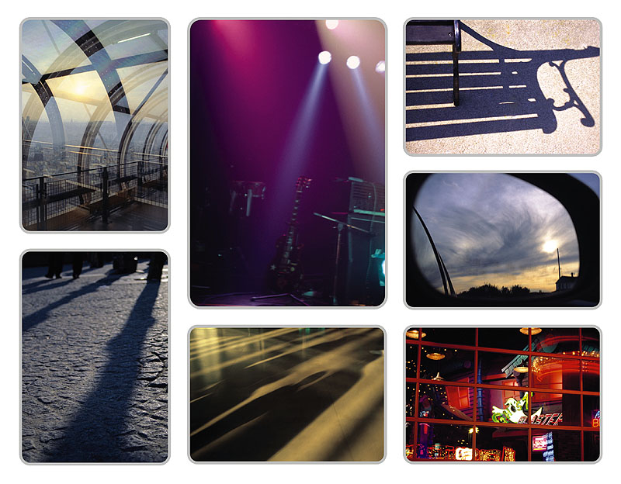
Target users：Web designers/editors, design artists, ad agents, related business people and students.
Suggested retail price：US$49

ID126 Money Market
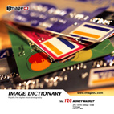
Quantity：75 images
Size：33MB
Format：21cm X 29.7cm / 300dpi
High-Resolution：JPG (CMYK) / 3508 x 2480 pixels
Low-Resolution：BMP (RGB) / 842 x 595 pixels
產品研發概述：

This collection broadens your clients’ view of the money market with business metaphors and concepts. You can easily link these images to your clients with crucial business situations and financial issues.

 Target users：Web designers/editors, design artists, ad agents, related
business people and students.
Suggested retail price：US$49

ID127 IT Background Design
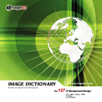
Quantity：75 images
Size：33MB
Format：21cm X 29.7cm / 300dpi
High-Resolution：JPG (CMYK) / 3508 x 2480 pixels
Low-Resolution：BMP (RGB) / 842 x 595 pixels

Applications of graphic arts, various digital symbols, and layered colors are intertwined in this collection. These images project to your clients a view of the modern technology and breathe the air of post-modernism.

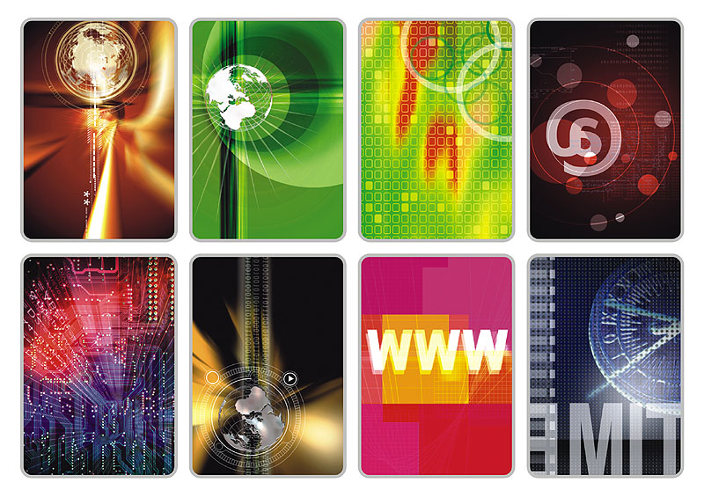
Target users：Web designers/editors, design artists, ad agents, related business people and students.
Suggested retail price：US$49

ID128 Money! Money!
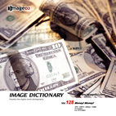
Quantity：75 images
Size：33MB
Format：21cm X 29.7cm / 300dpi
High-Resolution：JPG (CMYK) / 3508 x 2480 pixels
Low-Resolution：BMP (RGB) / 842 x 595 pixels

Money! Money! is the Atlas of international moneys. It delivers to your clients with images of present currencies worldwide, including various coins, bills and checks.

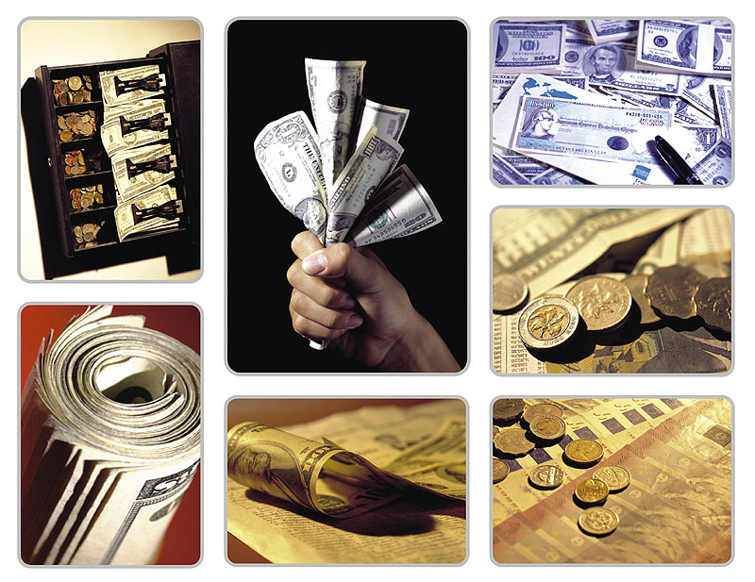
Target users：Web designers/editors, design artists, ad agents, related business people and students.
Suggested retail price：US$49

ID129 Summer Fun
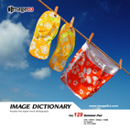
Quantity：75 images
Size：33MB
Format：21cm X 29.7cm / 300dpi
High-Resolution：JPG (CMYK) / 3508 x 2480 pixels
Low-Resolution：BMP (RGB) / 842 x 595 pixels

Summer Fun collects popular summer icons and images. Winter is gone. You need to refresh your clients’ memories of the summer fun time. This collection celebrates and awakes the viewers’ passion for the summer heat.

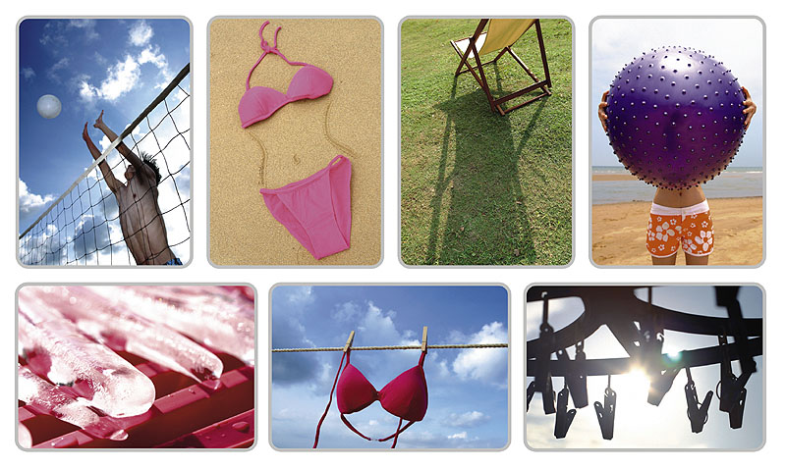
Target users：Web designers/editors, design artists, ad agents, related business people and students.
Suggested retail price：US$49

ID130 Feathers, Fabrics, Animal patterns

Quantity：75 images
Size：33MB
Format：21cm X 29.7cm / 300dpi
High-Resolution：JPG (CMYK) / 3508 x 2480 pixels
Low-Resolution：BMP (RGB) / 842 x 595 pixels

In this collection, we aim to capture the visuals of animal skins, clothes, feathers, and furs. These images finely depict the textures of the surfaces. They virtualize your clients’ genuine sensations of touch.

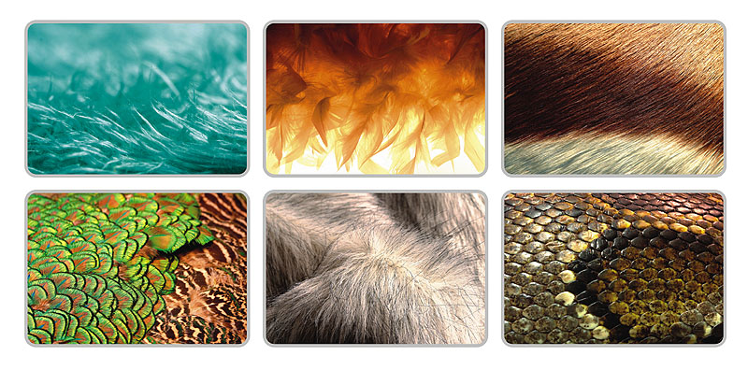
Target users：Web designers/editors, design artists, ad agents, related business people and students.
Suggested retail price：US$49

